

**Kent Cricket Academy &**

**Emerging Player Programme**

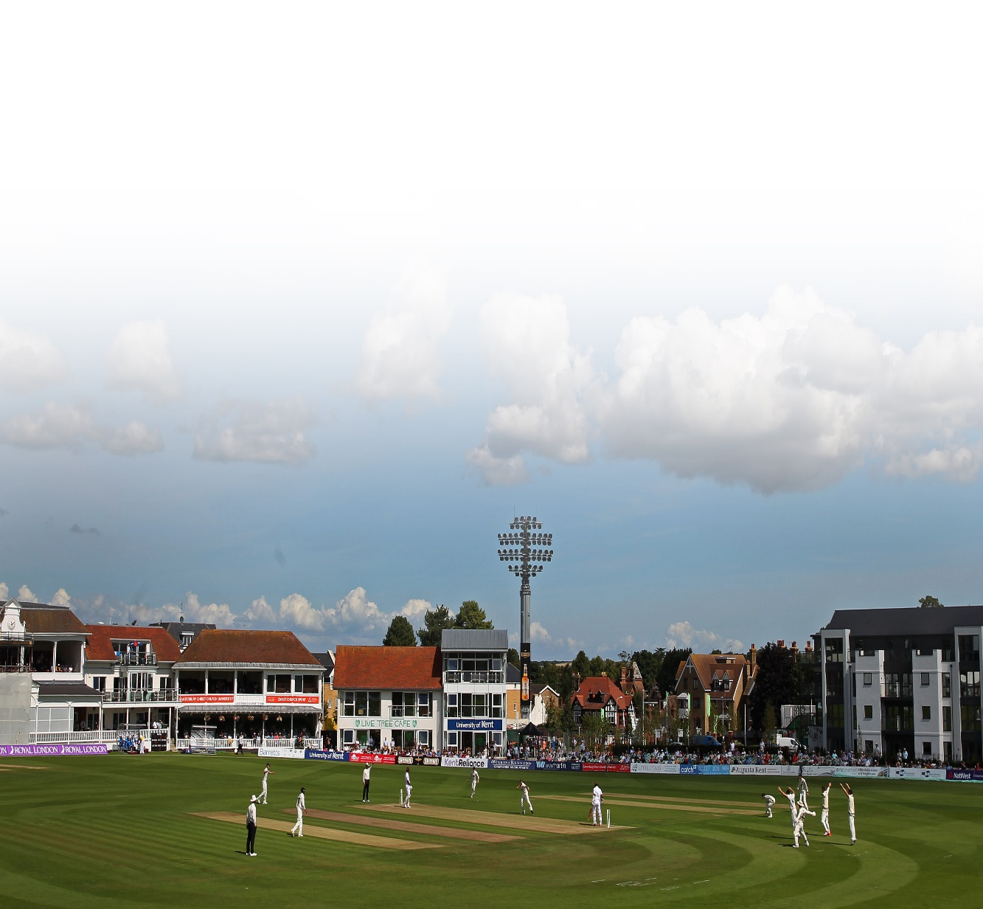

Annual Performance Plan 2019

**Contents**

1. Introduction
2. Vision

1. Yearly Plan
2. Player selection and development
3. Review of the Academy Programme
4. Academy roll of honour



1. **Introduction**

There are currently 18 ECB funded county academies. The purpose of the county academy system is to develop players capable of performing at first class and International level. Academy programmes are holistic in their approach and deliver a balance of technical, tactical, physical, mental, leadership and lifestyle skills.

Established in 2003, the Kent Cricket Academygives talented young cricketers, aged 16 – 19, an opportunity to benefit from professional training and education whilst still at school or college. The Academy aims to develop home grown players and prepare them for a future in the professional game.

The introduction of an ‘associate’ academy aims to provide additional support and development opportunities to players, aged 16 – 19, who have the future potential to gain a place on the full academy programme. The aim is to provide greater opportunity and visibility to a larger number of players within an elite environment.

Players on the associate programme will also be able to access high quality coaching and sports science support that incorporates a 'total life' approach. They will also have the opportunity at key points throughout the year to be moved through to the full academy programme.

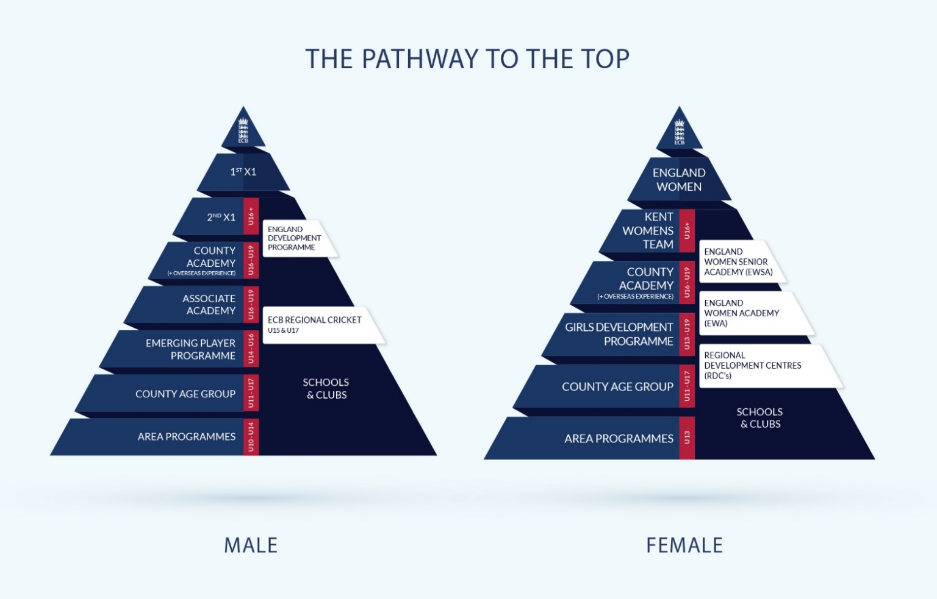The Emerging Players Programme (EPP) will provide additional support and development opportunities to players aged 14 – 16 and is a comprehensive and structured programme designed to help young players with the transition between the county age group squads and our academy programmes.

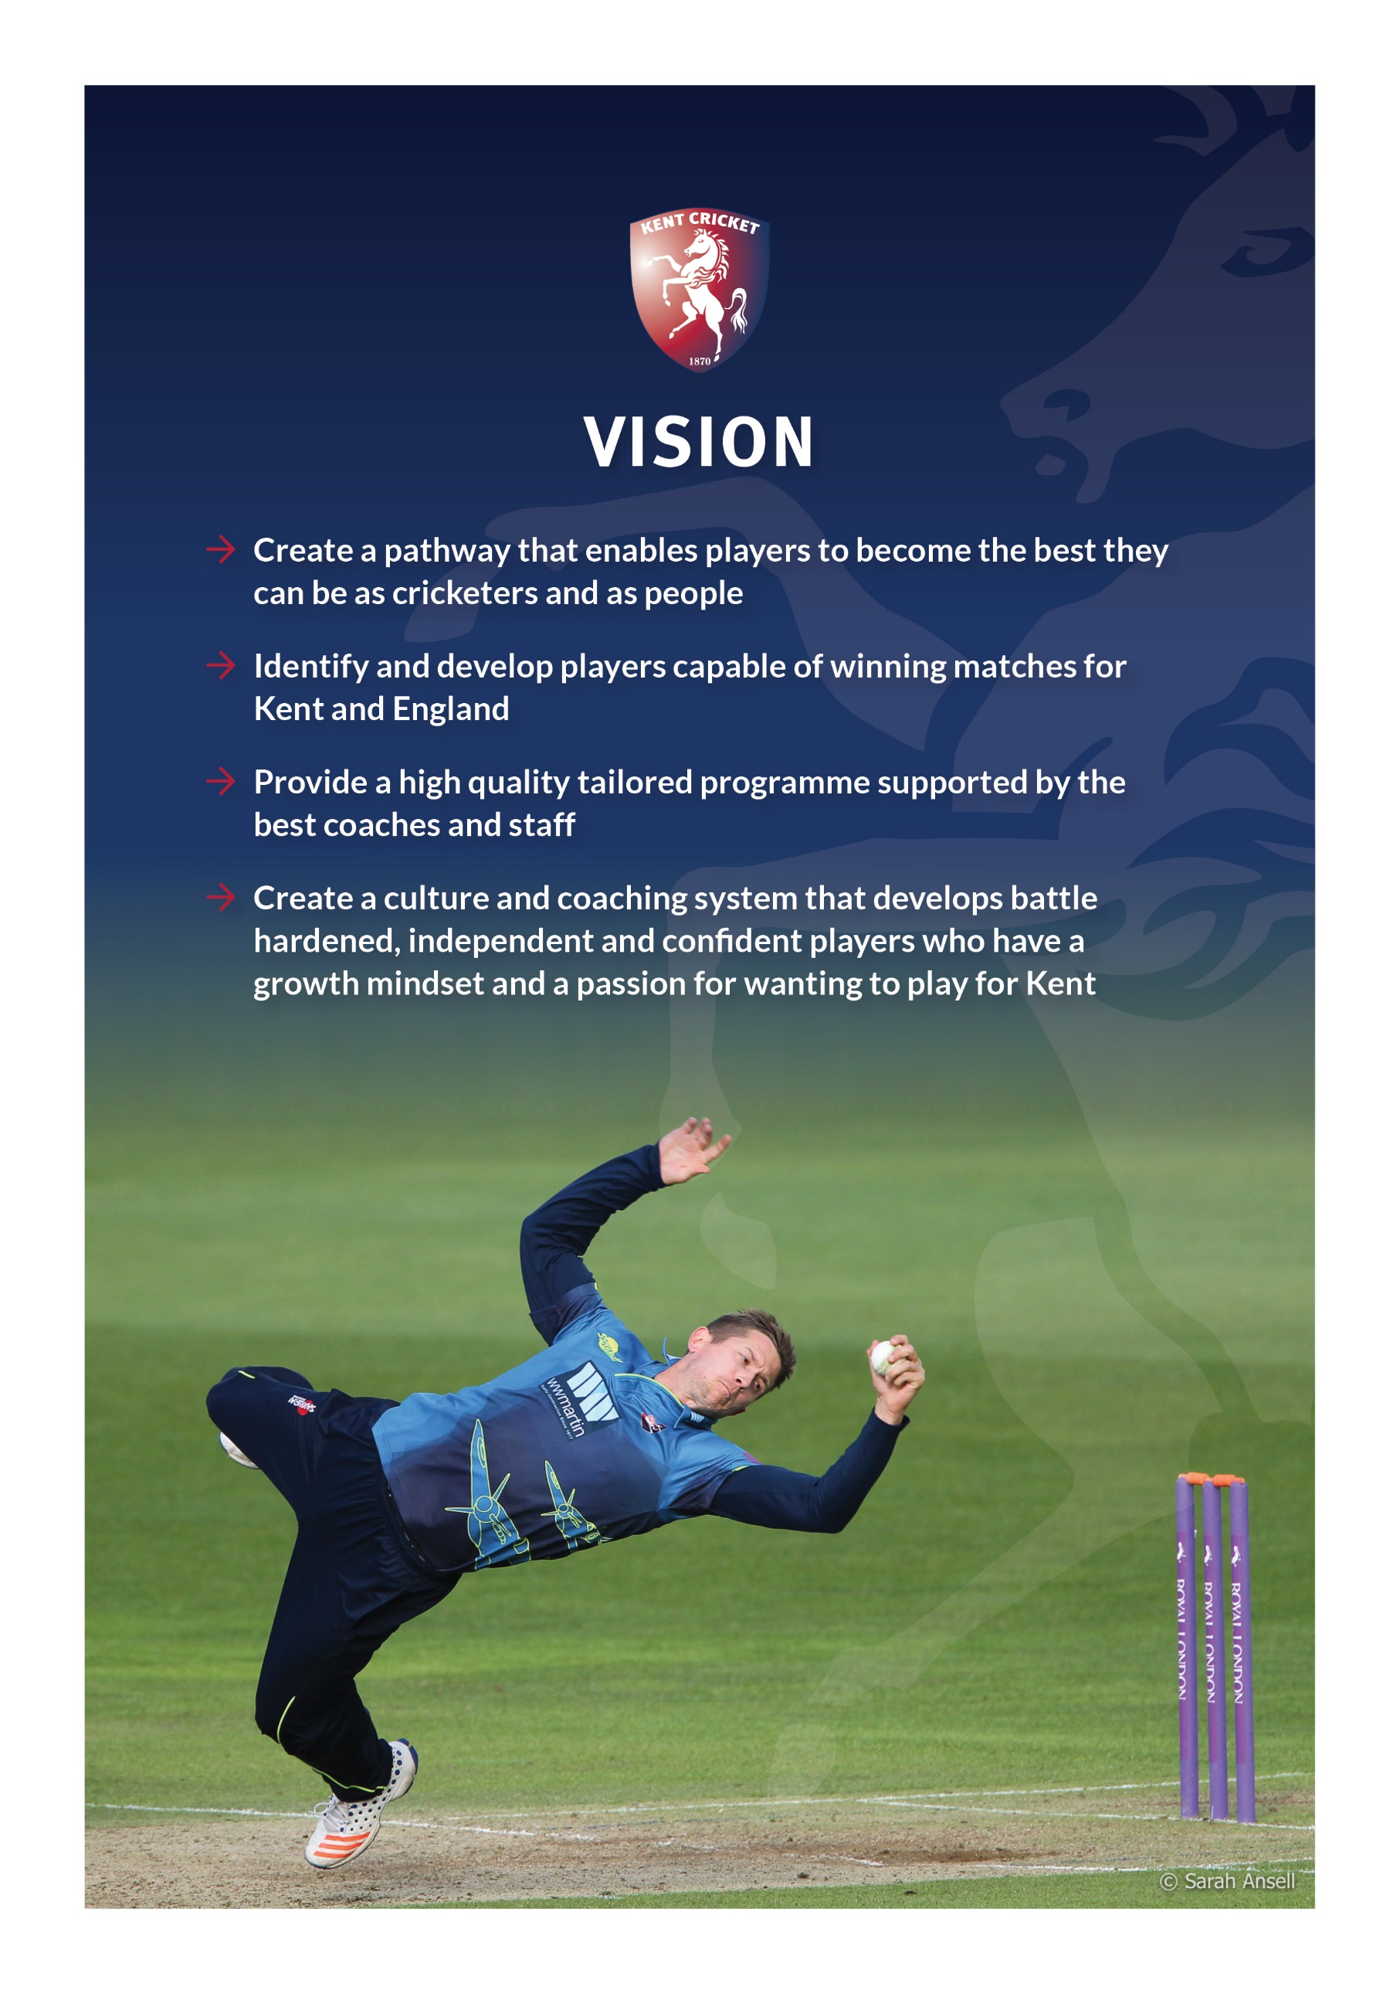

|  |  |  |  |  |  |  |  |  |  |  |  |  |  |  |  |  |  |  |
| --- | --- | --- | --- | --- | --- | --- | --- | --- | --- | --- | --- | --- | --- | --- | --- | --- | --- | --- |
|  |  |  |  |  |  |  | Oct | Nov | Dec | Jan | Feb | Mar | Apr | May | Jun | Jul | Aug | Sep |
| **Area** |  |  |  |  |  |  | **Module 1** | | | **Module 2** | | | | **Module 3** | | | | |
|  |  |  |  |  |  |  | **Assessment** | | | **Preparation** | | | | **Performance** | | | | |
| Parent induction and workshops | | | |  |  |  |  |  |  |  |  |  |  |  |  |  |  |  |
| Specialist skills sessions, including video analysis | | | | |  |  |  |  |  |  |  |  |  |  |  |  |  |  |
| Fundamental mental skills. 1:1 and group sessions | | | | | |  |  |  |  |  |  |  |  |  |  |  |  |  |
| Meeting and monitoring progress with school | | | | |  |  |  |  |  |  |  |  |  |  |  |  |  |  |
| Individual goal setting | | |  |  |  |  |  |  |  |  |  |  |  |  |  |  |  |  |
| Individual player reviews with High Performance Director | | | | | | |  |  |  |  |  |  |  |  |  |  |  |  |
| Introduction of online player management system | | | | | |  |  |  |  |  |  |  |  |  |  |  |  |  |
| AASE programme - introduction and meetings | | | | |  |  |  |  |  |  |  |  |  |  |  |  |  |  |
| Physical assessments | | |  |  |  |  |  |  |  |  |  |  |  |  |  |  |  |  |
| Professional cricket interaction | | | |  |  |  |  |  |  |  |  |  |  |  |  |  |  |  |
| Transition to game awareness sessions (all formats) | | | | | |  |  |  |  |  |  |  |  |  |  |  |  |  |
| Overseas experience | | |  |  |  |  |  |  |  |  |  |  |  |  |  |  |  |  |
| Academy training camp prior to the start of the season | | | | | | |  |  |  |  |  |  |  |  |  |  |  |  |
| Individually tailored fitness programme and support | | | | | |  |  |  |  |  |  |  |  |  |  |  |  |  |
| Lifestyle personal development programme (PCA) | | | | | |  |  |  |  |  |  |  |  |  |  |  |  |  |
| Performance squad training and match programme | | | | | |  |  |  |  |  |  |  |  |  |  |  |  |  |
| Academy match programme | | |  |  |  |  |  |  |  |  |  |  |  |  |  |  |  |  |
| Game toughness reviews within match play | | | | |  |  |  |  |  |  |  |  |  |  |  |  |  |  |
| Match play monitoring by selectors | | | | | |  |  |  |  |  |  |  |  |  |  |  |  |  |

1. **Kent Cricket Academy - timeline**
2. **Player selection and development**

The purpose of this document is to outline the systematic and structured method of selecting players onto the Kent Cricket Academy and Emerging Player programme (EPP). This is to ensure that those players selected are the players most likely to develop into first class quality cricketers capable of winning matches for Kent and England.

**Principles:**

The following principles should apply to the selection of players onto the academy programmes:

* Clear distinction between processes for Kent Cricket Academy and EPP selection and selection of Kent Performance Squads
* Kent Cricket Academy selection based on ‘demonstrated potential’ to develop into a first-class quality player over the next 5 to 8 years
* Selection onto the Kent Cricket Academy is intended to be highly competitive and challenging in order to encourage players to aim high to get into and, remain in the programme thus driving up standards of practice, preparation and performance across junior cricket in Kent.
* No fixed limit on the number of players in each year’s cohort. Normally no more than 12 players will be selected into any year’s cohort. On occasion the number may be greater or lower
* The introduction of an associate academy aims to provide additional support and development opportunities to players who have the future potential to gain a place on the full academy programme. Where appropriate associate players may be promoted to the Academy programme at any point throughout the year
* Players may be deselected from the Kent Cricket Academy if they fail to achieve their continued inclusion criteria. De-selections will normally be made in September annually. Following a performance review with the High-Performance Director please note that academy players may be deselected and placed on the associate academy programme at any point throughout the year.

**Selectors:** Jason Weaver, Matt Walker, Min Patel, Mark Dekker, Neil Taylor

Scouts / information Providers: County Performance Squad Head Coaches, ECB National Lead Skill Coaches, ECB Regional Performance Managers.

**Criteria:**

The following criteria will be considered by the selectors when selecting players for the Kent Cricket Academy and EPP programme:

* Scouting Reports
* Performance Statistics
* Injury status and risk
* Physical condition

Players will be ranked according to scouting reports, performance statistics and selectors experience separately and in combination. As well as the High-Performance Director undertaking visits and observations, a number of allocated ‘scouts’ will regularly observe and gather information on players, listed either on the long or short lists.

The scouts are information providers, not decision makers and they do not select squads or players for programmes but will be responsible for providing the selectors with information which will enable them to make effective decisions.

In identifying potential, ‘form’ can be misleading and this systematic process should prevent both good and poor form being misinterpreted for potential. Whilst, performance data will play a large role in indicating potential, selection onto the programme should not be seen simply as a reward for recent performance, but as an indicator of potential future performance.

Coaches experience for identifying potential will continue to play a role within selection, but it is hoped that this process will help gather evidence to support such intuition and will allow for improved cross-checking and validation.

**Proposed Annual Timetable:**

|  |
| --- |
| **Establishment of long list – May** |
| * List of players to be observed during the domestic season established * Information gathered to include general comments on skills, temperament, ambition, results   and potential   * Review of reports, action plans and historical performance data |
|  |
| **Scout Viewing 1 - May to June** |
| * Nominated scouts to observe players in county age group, club or school cricket * Further information to be gathered from county age group coaches * Short list of players to be observed during the second half of the season to be established * Previously non-identified players can be added at this stage |
|  |
| **Scout Viewing 2 - July to September** |
| * Scouts to observe targeted players in county age group or club cricket * Further information to be gathered from county age group coaches * Provisional final squad of players selected * Previously non-identified players can be added at this stage * Final Selection – end of September * Scholarship offer letters to be distributed to Academy, associate academy and EPP players |

**Induction Process**

**Exit Process**

**What are we looking for in our players?**

The tables below represent a summary of the ‘STAR’ qualities that we are looking for and are aiming to develop in our academy and Emerging Player Programmes. The **‘STAR’** qualities cover **skills, temperament, ambition and results**.

The list of qualities is designed to give coaches, players, parents and scouts guidance on what we are looking for and aim to develop within our elite programmes. We do not want to give the impression that we are looking for clones and we seek to provide guidelines rather than being overly prescriptive.

It will be rare for players to possess all of these qualities starting the programme, and the purpose of the EPP and Academy programmes is to develop these qualities over a period of time within a supportive environment. However, in order to select players for the programme; the potential to develop these qualities will be what we are looking to identify in our best players, as well as whether they already possess some of them.

The first table lists some general qualities that we believe our best players should possess on entry into a programme and the tables that follow describe each skill set and the characteristics attached to each skill.

In addition to the characteristics listed we will always encourage players to respect the game at all times, have fun and become the best they can be as cricketers and as people



|  |
| --- |
| **The Kent Way** |
| * Players who want to develop their skills to the best that they can be * Players who understand their game * Players who have pride in the ‘Horse’ * Players who have fun, embrace mistakes and are thinking cricketers |
| **Academy and EPP players** |
| Work ethic: Is able to take ownership and responsibility for their own game. Understands the CORE values associated with the environment  Learnability: Has an evolving growth mindset towards the game. Seeks out challenging situations and is able to maintain efforts in adverse situations  Self-confidence and belief: Possesses a positive (growth) mindset towards their game. Has an evolving shield of resilience that enables them to deal with different setbacks and disappointments on their journey  Self-awareness: Has an evolving appreciation of themselves as a person and as a cricketer. Is able to use constructive feedback to facilitate personal development.  Honesty: Is able to reflect on performances in a honest / open manner  Stays calm: Is able to manage and regulate their emotions both on and off the field. Is able to retain a positive body language when having to deal with disappointment and setbacks.  Concentration: Is able to manage and deal with those distractions present both on and off the field.  Multi skilled in batting, bowling, fielding or wicket keeping with two of these skills seen as specialist strengths. A leading player amongst peers.  Good athletic potential: Endurance, flexibility, strength, speed  Diet: Eats and drinks healthily / rehydrates and recovers properly.  Balanced lifestyle: Has interests outside of cricket and is able to switch off from game. Commits to school & college work.  Desire to play cricket for Kent |

|  |
| --- |
| **The Kent Way: Batting** |
| * Dynamic, skilled and smart players * Positive players in all aspects of their game * Clear minded cricketers with a contented understanding of their game * Players that want to be challenged |
| **Academy and EPP Players** |
| Balance: Is able to play ball from a balanced position.  Excellent judgement of length and is able to make correct decisions.  A set up that allows players to be still at point of release and in an appropriate position to play ball.  Has the ability to move quickly into position – forwards and back, quick feet  Plays ball under eyes: Is able to play ball late and make contact with head over ball.  Attack v pace: has the ability to hit bad ball for 4/6 and manipulate ball into gaps. (Front foot and back foot).  Defence v pace – can leave ball effectively, evade and play defensively with a straight bat. (Front foot and back foot).  Attack v. spin - can hit bad ball for 4/6 and manipulate ball into gaps as well as being able to use feet. (Front foot and back foot).  Defence v spin – able to defend competently against spinning ball. (Front foot and back foot).  Game awareness: adapts to different situations, bowlers and conditions. Can implement a Plan B.  Courage: play positively in tough circumstances – this could be defending against spin with close fielders around the bat on last day.  Running between wickets: judges a run well, runs aggressively, turns well, positive attitude towards running.  Stamina: Is able to play long innings and maintain energy levels throughout.  Performance: Has the ability to play match winning innings. Scores runs at a high average/ has good strike rates/ scores in difficult situations/ dominates weak bowling attacks/ converts to big scores regularly. |

|  |
| --- |
| **The Kent Way: Pace Bowling** |
| * Pace: Has the ability to get carry, bounce and hits the bat hard * Consistency, consistency, consistency * A master of variation * Competitors |
| **Academy and EPP players** |
| Has the ability to put pressure on opposition.  Safe consistent repeatable action / technique.  Pace – gets carry and bounce and hits the bat hard.  Variations: Is able to “do something with the ball” in the air or off the pitch.  Aggressive mind set and real desire to take wickets.  Corridor width: All movements direct towards a target. - moving within a shoulder width corridor throughout action.  “Natural” – flowing, athletic movement.  Assesses situation – develops a plan according to stage of the game, batters and pitch conditions. Including the ability to set fields.  Control of line and length: Has the ability to hit good areas consistently and bowls to a field / plan (Patience).  Physical attributes: Core stability, athleticism, flexibility, endurance, speed, strength  Performance: Has the ability to be match winner and takes wickets at a low strike rate/ takes wicket at a low average/ has a good economy rate in shorter format game. |

|  |
| --- |
| **The Kent Way: Spin Bowling** |
| * Has the ability to spin the ball * Control of line and length * Has the ability to bowl variations * Competitors |
| **Academy and EPP Players** |
| Has the ability to put pressure on opposition  Amount of spin: gets different types of spin (curve, drop, side) with optimum revs.  Control of line and length: Has the ability to hit good areas consistently and bowls to a field plan.  Safe repeatable action. All movements direct towards a target.  Has good alignment, base, circles and drive.  Variations – able to bowl an alternative delivery consistently.  Patience – to be able to toil away and work to a plan.  Assesses situation – develops a plan according to stage of the game, batters and pitch conditions, Can set fields accordingly and understands fielders ‘angles’.  Has the ability to vary pace, use crease / bowl over and around wicket.  Corridor width: Aim to keep all body parts moving within a shoulder width corridor throughout action.  Fields well off own bowling  Physical attributes: Flexibility, strength and stamina  Performance: Has the ability to be a match winner and takes wickets at low average/ takes wickets at a low strike rate/ has a good economy rate in shorter format games. |
| **The Kent Way: Wicketkeeping** | |
| * Catches the ball consistently * Ability to be a leader in the field | |
| **Academy and EPP Players** | |
| Maintains large catching area.  Few errors: Takes chances - catches & stumpings.  Has the ability to maintain strong posture.  Balance: Weight is on balls of feet and eyes are level when catching ball.  Footwork: Simple method that allows keeper to get in a position to catch the ball efficiently with head and hands close together. (Standing up and back)  Sharp reflexes.  Shows presence on the field.  Ability to be a leader: sets and maintains a high ‘tempo’/ communicates well / energetic / supports team mates  Diving – ability to get to balls on off side and leg side by diving.  ‘Busy’ around the stumps looking for run out opportunities and tidying throws  Assesses conditions and opposition: Dictates positioning of close fielders/ knows when to stand up to pace bowlers and analyses batsman to help bowlers plans.  Physical attributes: Agility, speed, power and stamina.  Has the ability to bat in top 7 of a county age group side.  Performs well in county age groups and league level. | |
| **The Kent Way: Fielding** | |
| * Players who have the desire to be the best fielder they can be * Regard fielding as important as batting and bowling * To be athletic in body and energetic in mind | |
| **Academy and EPP players** | |
| Observable strength.  Presence on the field and puts opposition under pressure.  Awareness of all that is happening on the field – ‘reads the game’ (backing up/supporting team-mates).  Ready position: gets into a consistent athletic set position at point of contact.  Has a specialist position in field.  Large catching area: Able to catch with fingers down and reverse hands/ reliable in close and in deep.  Underarm throw and dive from infield – accurate and quick release.  Overarm throwing from infield & outfield – accurate from the circle and from boundary.  Physical attributes: agility, speed, flexibility, stamina and strength.  Performance: Takes wickets through catching and ground fielding. Saves runs in the field. | |

**5. Review of the Academy and EPP Programme**

Good communication between the Academy and EPP staff helps to develop a positive and supportive relationship that enables the players to achieve the best of their ability. It is essential that we have systems in place to help us maintain good communication.

**Staff Meetings:**

We like to consult with the staff so that we can gain their views about the Academy. We may also need their views on any new developments or new initiatives. To enable us to consult with the staff regularly we like to arrange to meet as a group three times per year preferably in the last week of each module.

**Annual Staff Survey:**

We complete an annual series of confidential player, parents and staff surveys. The aim of this information gathering is to produce a review of the past year and receive feedback which we hope will help influence the direction we take the Academy in the future.

We are very keen to have as many staff complete the survey as possible so that we get a broad perspective from those individuals who have been directly involved with the Academy and EPP programme over the previous twelve months.

**7. Academy Roll of Honour**

Since the establishment of the Kent Cricket Academy in 2003 the following Kent age group players have made their debuts for Kent senior teams.

|  |  |  |  |
| --- | --- | --- | --- |
| **Name** | **First Class** | **List “A”** | **Twenty 20** |
| Joe Denly  Simon Cusden  Lydia Greenway  Joanna Watts  Paul Dixey  James Iles  Alex Blake  Sam Northeast  Tom Parsons  James Goodman  Tamsin Beaumont  Matthew Coles  Warren Lee  Adam Ball  Chris Piesley  Adam Riley  Daniel Bell-Drummond  Sam Billings  Ivan Thomas  Deanna Cooper  Alice Davidson Richards  Fabian Cowdrey  Natasha Farrant  Grace Gibbs  Ryan Davies  Hugh Bernard  Oliver Robinson  Zak Crawley | 2004  2004  2005  2006  2008  2007  2010  2009  2011  2010  2011  2011  2011  2012  2014  2015  2016  2018  2017 | 2004  2004  2004  2007  2007  2007  2007  2007  2007  2007  2009  2009  2010  2011  2011  2011  2011  2014  2008  2010  2013  2012  2013  2017  2017  2017 | 2004  2004  2005  2010  2010  2008  2010  2011  2012  2013  2011  2015  2011  2010  2013  2013  2012  2015 |

Since the establishment of the Kent Cricket Academy in 2003 the following Kent age group players have made their debuts for England senior teams.

|  |  |  |  |
| --- | --- | --- | --- |
| **Name** | **Test** | **One-day** | **Twenty 20** |
| Lydia Greenway  Joanna Watts  Joe Denly  Tamsin Beaumont  Natasha Farrant  Sam Billings  Alice Davidson-Richards | 2003  2013 | 2003  2005  2009  2009  2013  2015  2018 | 2004  2009  2009  2013  2015  2018 |

1. **Staff**

**Jason Weaver: High Performance Director**

* Has been in current role since May 2016
* ECB Level 4 coach
* Previously employed by ECB as Coach Education Manager
* Previously employed by Kent Cricket Board as High-Performance Manager
* Full time employment contract with Kent CCC
* Contact: jason.weaver.kent@ecb.co.uk

**Laura Carpenter - Friend: Administrator**

* Has been in current role since April 2018
* Previously employed by Kent County Council
* Primary Education Degree

**Adam Taylor: Strength & Conditioning Coach**

* Has been in current role since 2015
* Masters degree in Strength and Conditioning
* Previously employed as an intern with Leicestershire CCC and Warwickshire CCC
* Full time employment contract with Kent CCC

**Nimmo Reid: Physiotherapist**

* Has been in current role since 2013
* 2006-2013 Kent CCC 1st XI Physiotherapist
* BSc (Hons) Physiotherapy
* Full time employment contract with Kent CCC

**Sion Thomas: Psychologist**

* Has been in current role since the Academy was established in 2003
* BASES Accredited Sports Psychologist Pg. Cert (Couns)
* BSc Sports Science, MSc Sports Science
* Presently working with Charlton Athletic FC, England Hockey and Netball, UKA. Senior Lecturer in Sport and Exercise Psychology (University of Greenwich, 1999 – current)
* Part time self-employed consultant

**David Nash: Child Welfare Officer**

* Has been in current role since 2011
* Has attended ECB Safe Hands Club Welfare Officer Refresher Workshop in 2013
* Teaching diploma (Cert Ed), BEd in Geography
* Previously employed by Kent Cricket Board as County Welfare Officer
* Part time self-employed consultant
* Contact: two_nashies@hotmail.com